
Prepared By: Javra Software Nepal
Date: Thursday, 20 August 2015
Laser Api User Guide
LJ-V7000 Series

Introduction

The LJ-V7000 Series is the first 3D laser inspection system in the world to adopt a blue laser. The LJ-V7000 Series was designed to achieve the world’s fastest sampling speed. It can measure products moving on high speed lines with high precision and no loss of data.

In Euro-Mit main purpose of laser device is to measure the burr, sharpness of steel, camber, wave height, thickness of steel, etc. At present Euro-Mit has two working laser head which ip Address is 192.168.196.18 and 192.168.196.19 respectively.

Task of javra software is to capture the data from laser device and set it in to the Euro-Mit x/e files. For this purpose Euro-Mit provided us a dll file through this we need to communicate the laser to the x/e files. We did research to communicate with this dll but finally we decided that we cannot return output from this device because this dll consists of methods that cannot be access from Progress Openedge 4gl. To solve this problem we used Com Component of .Net technology and we made another dll and tlb file which we can access from progress openedge 4gl.

Assembled Files
- LJV7_IF.dll
- LJV_Dllconsolesample.dll
- LJV_Dllconsolesample.tlb

Installation guide for Dll
- First of all please install .Net framework 3.5 on your System.
- Run command prompt from Administration privilege.
- Point the Regasm.exe file path to the command prompt.
Normally Path will be like “C:\Windows\Microsoft.NET\Framework\v2.0.50727”.
- Type Following command
regasm.exe [.dll file with full path] /tlb:[.tlb file with full path] /codebase
- Finished.

Modification on Euro-Mit X/E files

- Go to Planning and production menu.

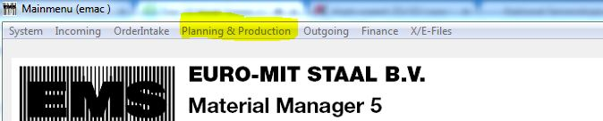

- After that click on Task Mgt (measure) Sub-menu.

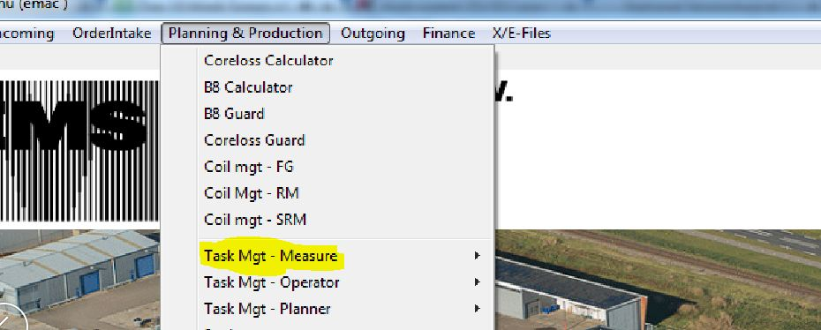

- Click any columns of browser fields and go to slits tab.
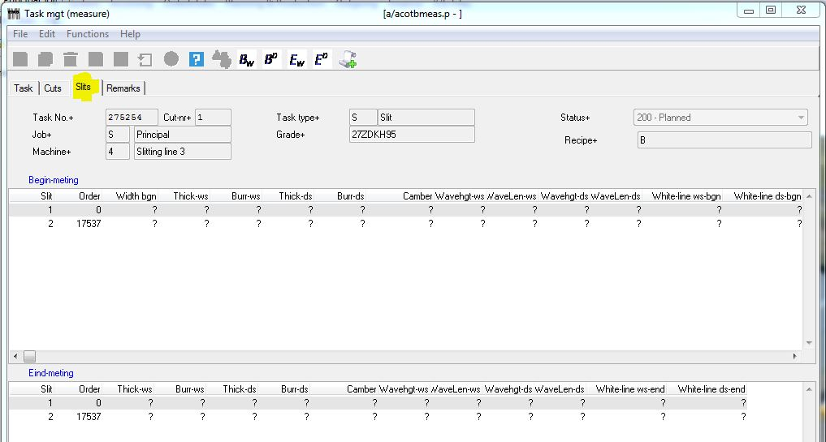
- In the above tool slits you can see Bw, Bd, Ew, Ed where Bw and Ew use for Ip Address 192.168.196.18 (Begin Meting and Eind Meting) and Bd and Ed use for Ip Address 192.168.196.19 (Begin Meting and Eind Meting).

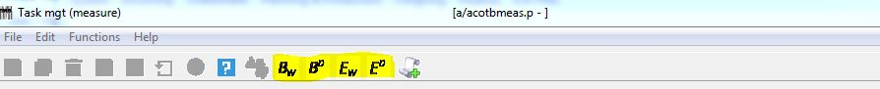

- Select any columns from Begin – Meting then click on either Bw or Bd. Then data which is in the laser navigator are insert on this column. (Please check practically).

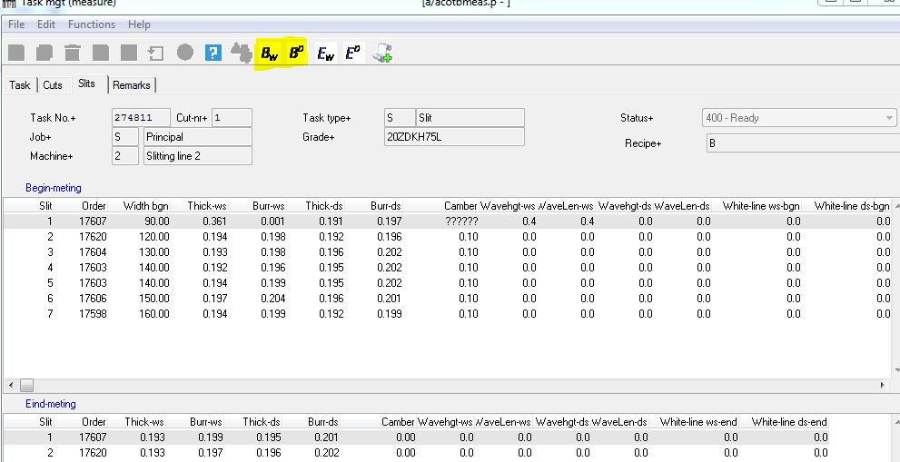

- Select any columns from Eind – Meting then click on either Ew or Ed. Then data which is in the laser navigator are insert on this column. (Please check practically).

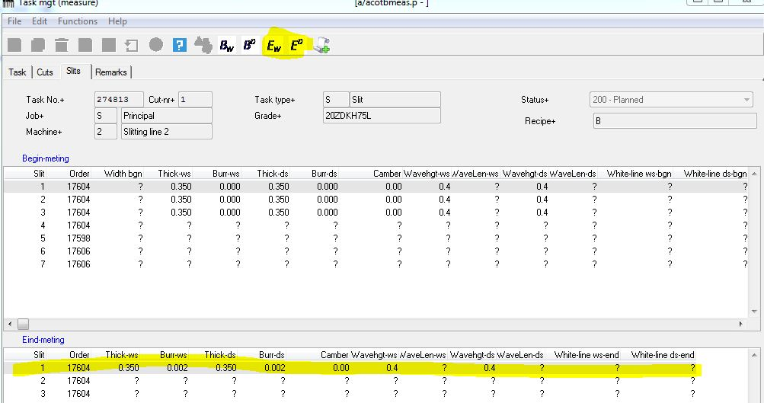

Note: - Compare the data between Laser navigator and Task mgt (measure) columns data.

Setup IP Address in X/E Files
Ip Address can setup from the extra setting in the x/e files. Currently we configured two Ip Address and port in two columns.
Setup Steps
- Go to X/E files menu
Admin
Extra Setting

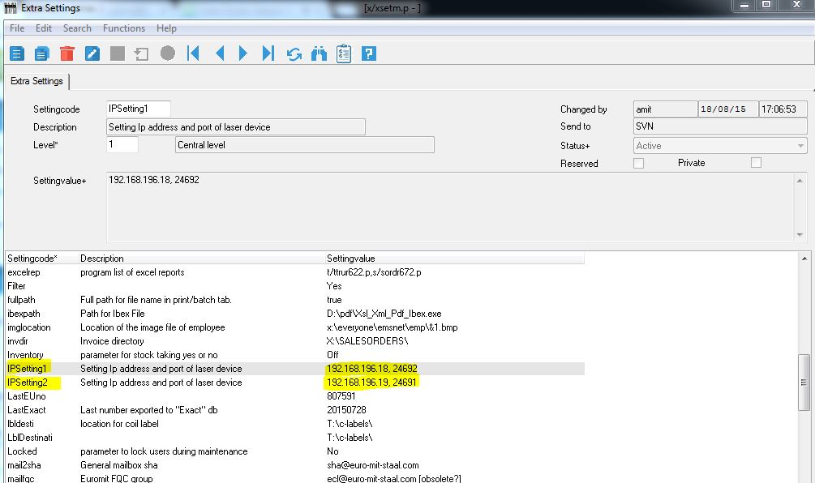

You can set up Ip Address from above program.

